Caroline Cliona Boyle

Data Journalism

Prof. Minkoff

February 25, 2022

**Story 1 —** **Measuring the incidence of Capitalism and Socialism in Contemporary Literature**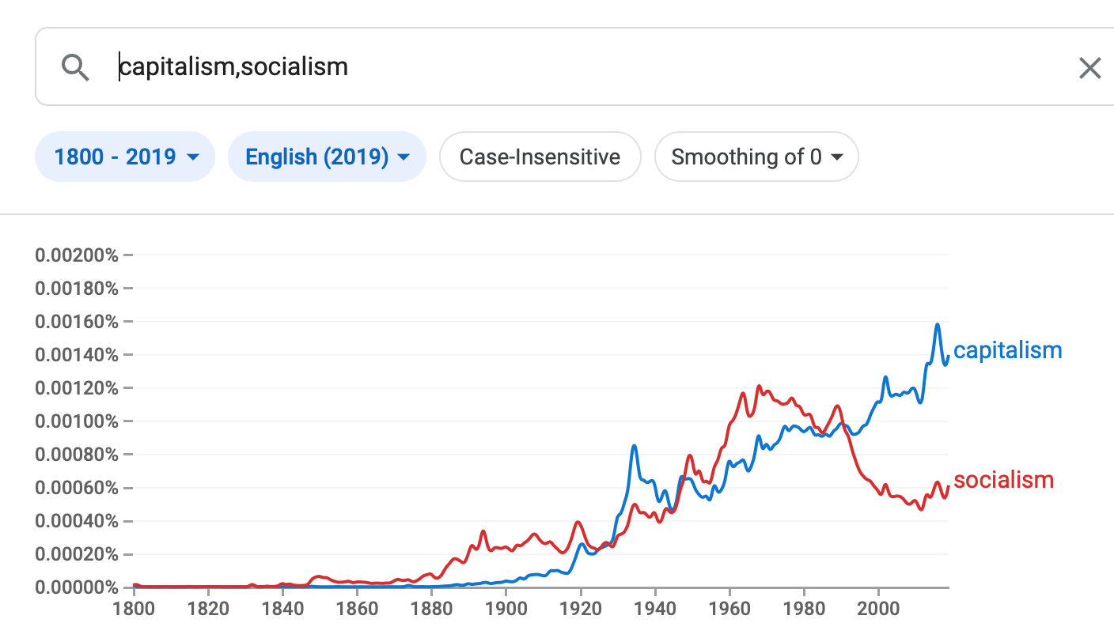

Debates around the best economic and political system to instill in a nation-state have existed for decades. As economic and social inequality continues to persist across the world, the evolving discussion around capitalism and socialism is ever so relevant.

Literature around capitalism dates back to the enlightenment period, when Scottish philosopher Adam Smith wrote “The Wealth of Nations,” a book that conceptualized the replacement of the mercantilist economic system with an industrialized society based on free trade. As exhibited on the chart, significant discussions about capitalism began during the Industrial Era, which spanned from the 1870s to 1900.

Conceptualizations of socialism emerged in the early 20th century, spearheaded by the prominent philosophers Karl Marx and Friedrich Engels. Marxist theory became the basis for communist philosophy in nation states during the early 1900s, and this is reflected in the steady rise of discussions around socialism from 1900 to 1960. In America’s current political climate, supporters of right-wing ideologies often conflate the terms socialism and communism as leverage to justify the capitalist system in place. These ideologues consider socialism to be an over-reach of government power, rather than a system that supports all facets of society in an equitable manner.

The debate around capitalism and socialism has existed as long as both terms have been used in modern economic literature, exhibited in the steady incidence of capitalism in literature alongside from 1900 to 1960, in tandem with socialism. The decline of incidences of socialism from 1970 onward is of significant note, with many possible extrapolating factors at play.

**Story 2 — Kanye West and Pete Davidson: The ex-husband and the new boyfriend**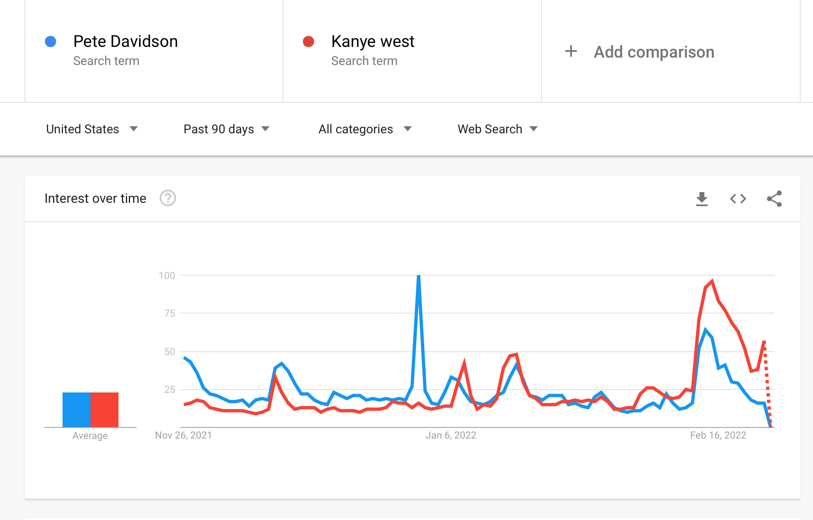

2022 has been an incredibly interesting time for pop culture. Whether you take an interest in the livelihood of the Kardashians or not, their impact on emerging trends in fashion, beauty, and media is undeniable. What’s so stirring about the past two months for the Kardashian clan has been the very public one-sided feud between Kanye West, Kardashian’s ex, and Pete Davidson, Kardashian’s new boyfriend.

Back in November, Pete Davidson was linked to Kim Kardashian. Paparazzi captured the pair having dinner at high-end restaurants in Los Angeles, and quite publicly followed Kardashian and Davidson on their vacation to Jamaica. Thus, a rise in keyword searches for Pete Davidson over Kanye West is fairly consistent at the time.

In early January, there was a significant spike in searches for Pete Davidson over Kanye West. This can be attributed to a controversy in which Pete Davidson reportedly partied with Miley Cyrus after they hosted an SNL New Year’s Eve special together. What was so controversial about this is that Davidson is purported to have cheated on Kardashian on this day, resulting in a massive social media discussion over Davidson’s and Kardashian’s relationship.

Finally, a spike in interest in both Kanye West and Pete Davidson in mid-February of this year is the result of West’s Instagram posting spree that took the internet by storm. He posted multiple photos of Kim Kardashian, their children, and Pete Davidson discussing their new relationship. These posts have since been deleted, and search interest in both parties have now started to decline.